## **WEEK - 5 ( ASP.NET Core Web API Microservices )**

**Install every package required**

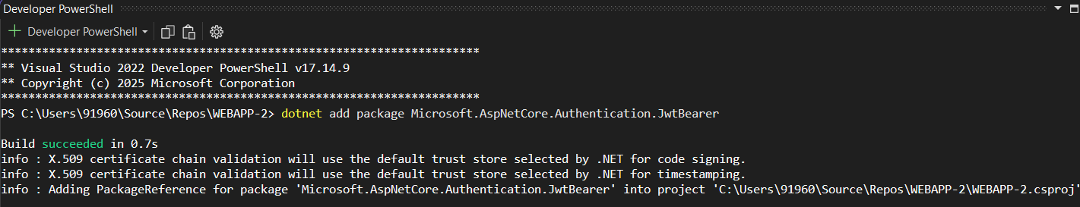

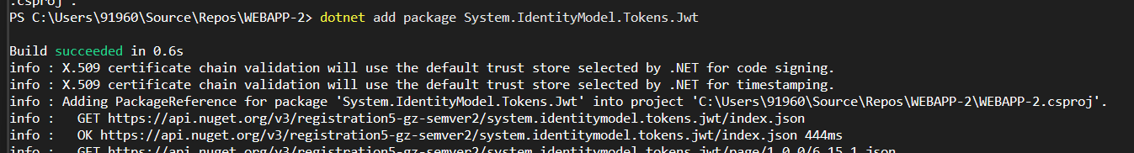

**Install swashbuckkel package**

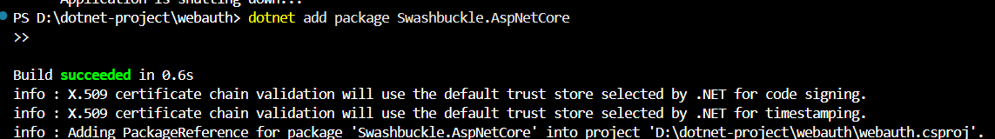

**Project folder strucutre:**

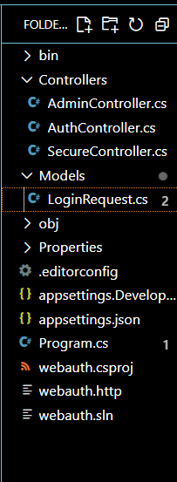

**Program.cs :**

**using Microsoft.IdentityModel.Tokens;**

**using System.Text;**

**var builder = WebApplication.CreateBuilder(args);**

**// Add services**

**builder.Services.AddControllers();**

**builder.Services.AddEndpointsApiExplorer();**

**builder.Services.AddSwaggerGen();**

**// JWT Key, Issuer, Audience**

**var jwtKey = "a1b2c3d4e5f6g7h8i9j0k1l2m3n4o5p6q7r8s9t0u1v2w3x4y5z6";**

**var issuer = "http://localhost:5242";**

**var audience = "http://localhost:5242";**

**builder.Services.AddAuthentication(JwtBearerDefaults.AuthenticationScheme)**

**.AddJwtBearer(options =>**

**{**

**var keyBytes = Encoding.UTF8.GetBytes(jwtKey);**

**options.TokenValidationParameters = new TokenValidationParameters**

**{**

**ValidateIssuer = true,**

**ValidateAudience = true,**

**ValidateLifetime = true,**

**ValidateIssuerSigningKey = true,**

**ValidIssuer = issuer,**

**ValidAudience = audience,**

**IssuerSigningKey = new SymmetricSecurityKey(keyBytes)**

**};**

**options.Events = new JwtBearerEvents**

**{**

**OnAuthenticationFailed = context =>**

**{**

**if (context.Exception is SecurityTokenExpiredException)**

**{**

**context.Response.Headers.Add("Token-Expired", "true");**

**}**

**return Task.CompletedTask;**

**}**

**};**

**});**

**builder.Services.AddAuthorization();**

**var app = builder.Build();**

**app.UseSwagger();**

**app.UseSwaggerUI();**

**app.UseHttpsRedirection();**

**app.UseAuthentication();**

**app.UseAuthorization();**

**app.MapControllers();**

**app.Run();**

**Swagger window :**

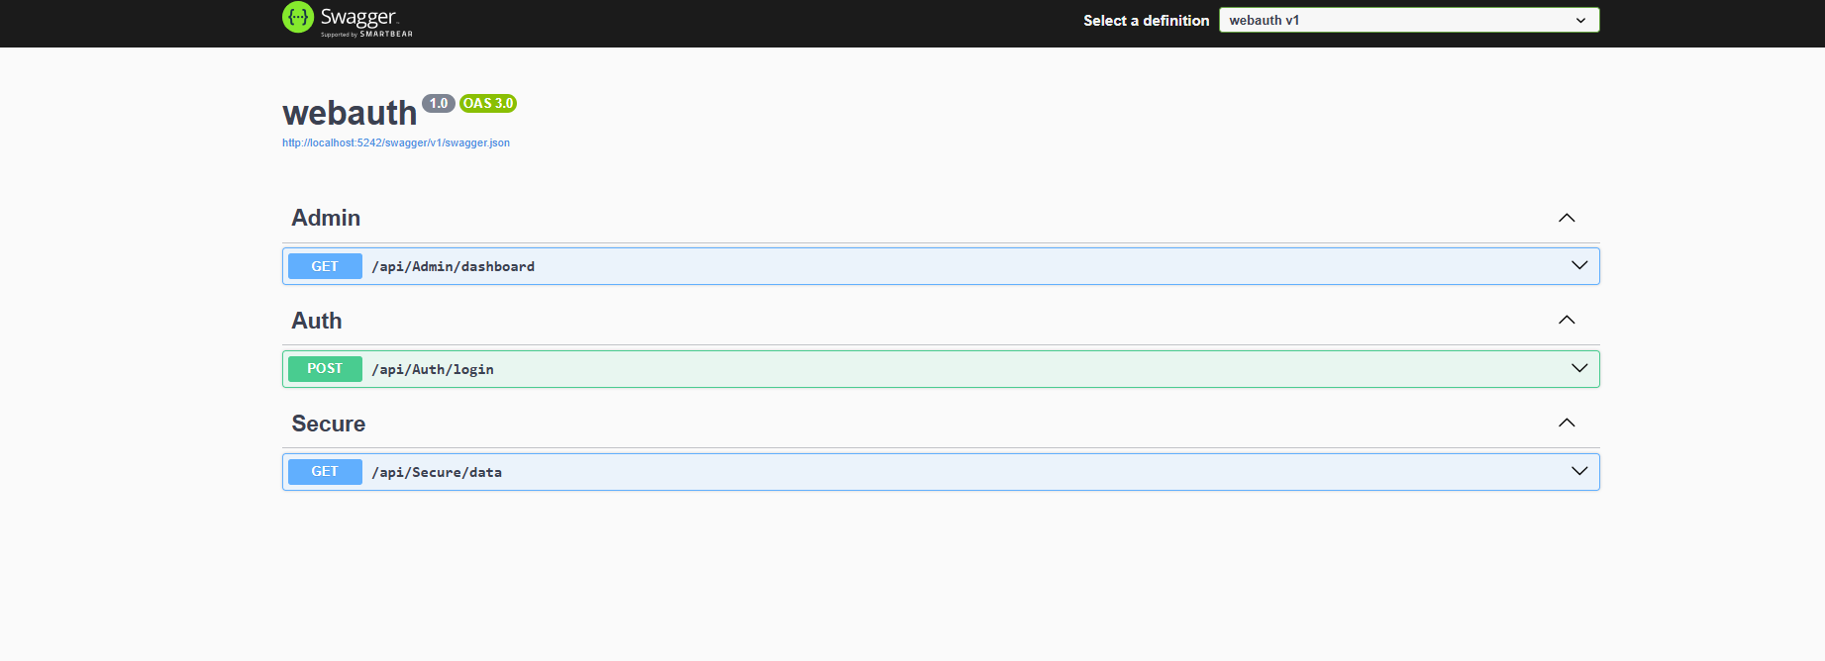

**Output testing in Swagger after Question 2**

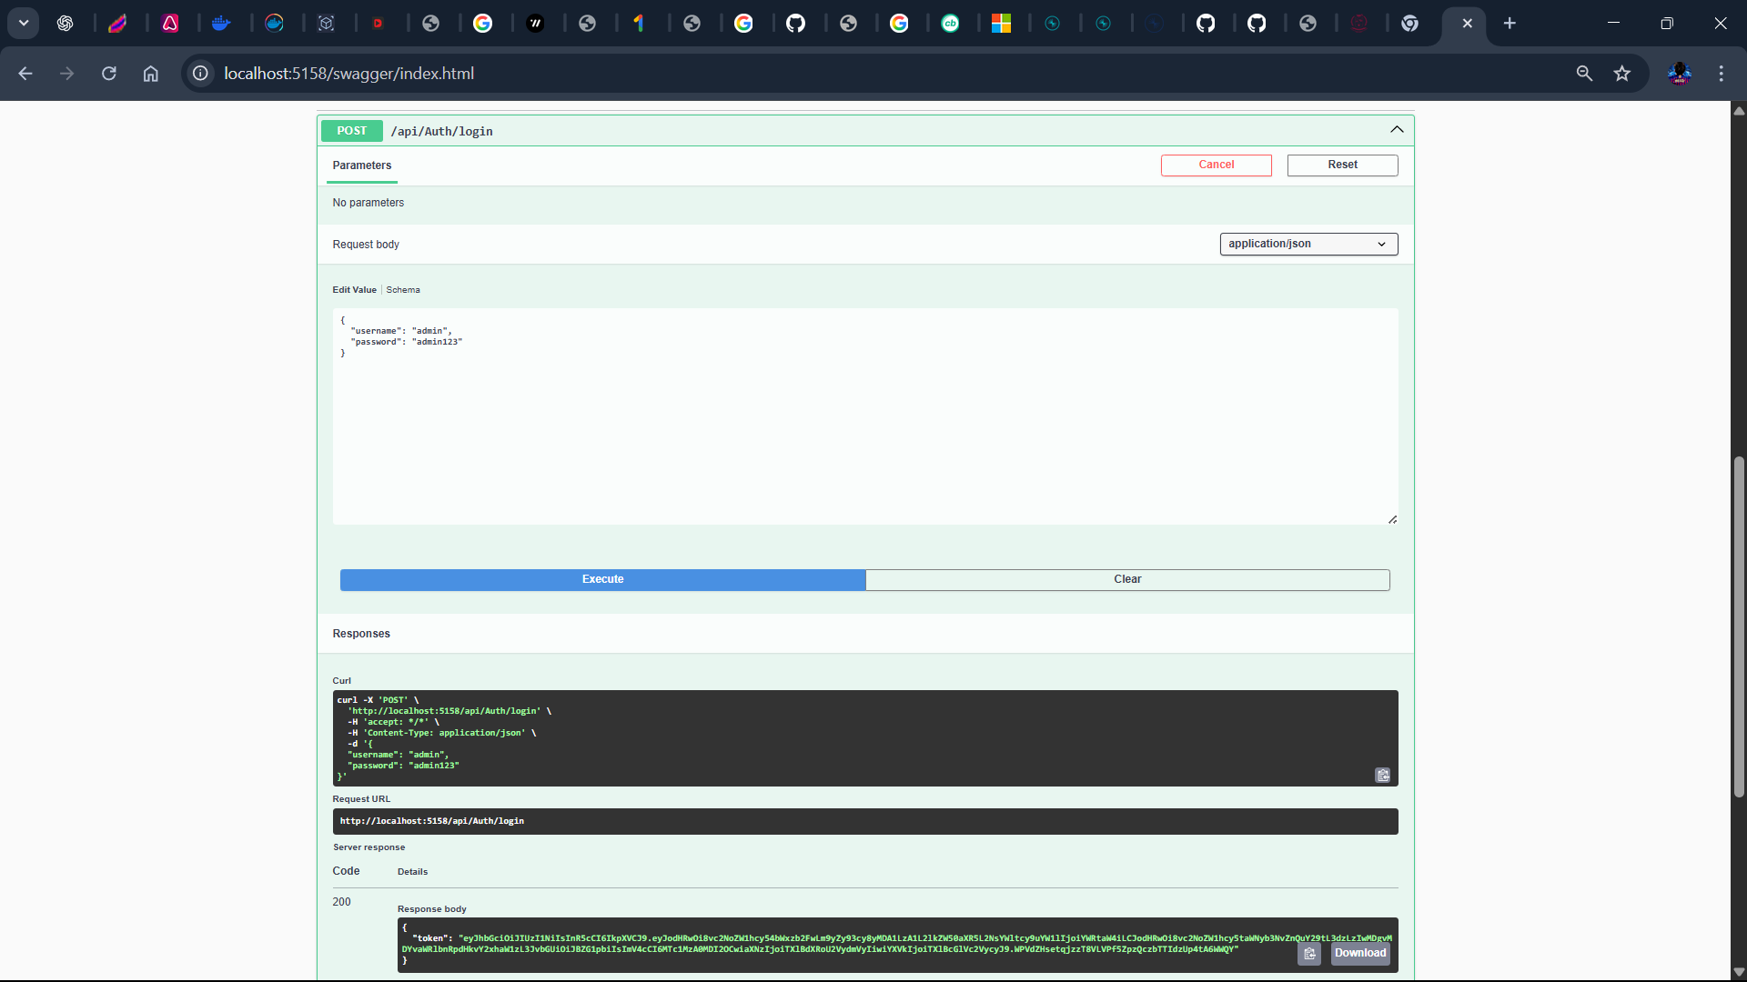

**In postman**

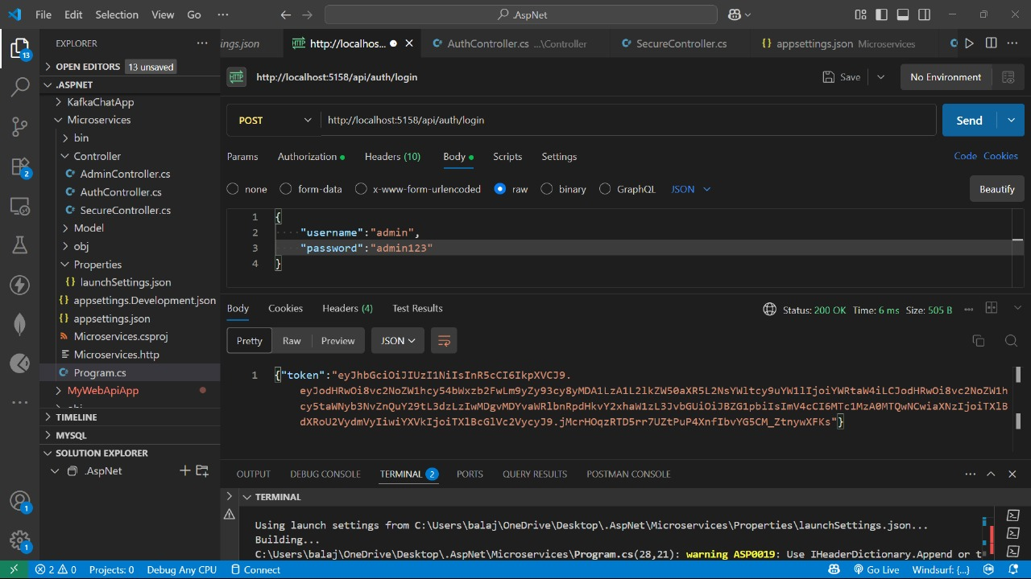

**Question 3 Output :**

